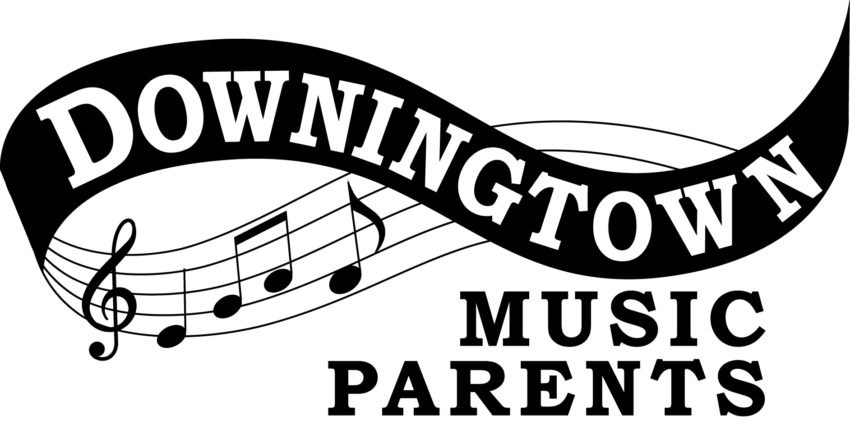 | The Brent Lewis - Theodore C. Smith IV Commemorative Scholarship  Page 1
Application for Brent Lewis – Theodore C. Smith IV Commemorative Scholarship
Sponsored by:
Downingtown High School Music Parents Association

Applications for this scholarship may be obtained from your guidance counselor, music director, the school website or can be downloaded from the DHSMPA website at www.dhsmpa.org.

This scholarship for senior Downingtown High School Band Members will be in the amount of $1000.00 and will be awarded to one band student (band, drums, guard) from each Downingtown East and Downingtown West (STEM inclusive). This award will be sent directly to your enrolled institution.

Instructions:

- Applications received postmarked after March 31, 2017 will not be accepted
- Application Essay must be typed and double spaced
- Application information should be kept as anonymous as possible
- Do not turn in a personal resume
- Application pages MUST be single-sided only
- FAILURE TO FOLLOW ANY AND ALL INSTRUCTIONS WILL DISQUALIFY YOUR APPLICATION.

The application must be returned to the
MPA Post Office Box at the address below
and postmarked no later than March 31, 2017.
NO APPLICATIONS WILL BE ACCEPTED GIVEN
TO GUIDANCE COUNSELORS NOR TO MUSIC DIRECTORS.

Downingtown High School Music Parents Association
Attn: MPA Scholarship Committee
PO Box 606, Downingtown, PA 19335

Identification Code: _______________________
(to be completed by committee)

I am a band student at Downingtown (circle): East or West High School
(please circle one)

Brent Lewis - Theodore C. Smith IV Commemorative Scholarship

Theodore (Ted) Smith was a senior in the Downingtown High School Band during Mr. Lewis’s first year of teaching. Ted was a fine musician, a hard working student and an extremely dedicated band member whose commitment to the good of the band was far more important than his own individual needs. Enjoying the company and comradery of his fellow band members, Ted thrived as a member and enjoyed the love, respect, and friendship of all involved.

Ted tragically was afflicted with an illness (cancer) that within a year or two took his life. Despite his illness, and debilitating medical treatments, Ted continued to give his very best up and until he no longer could play his trombone. The following fall, physically unable to attend his beloved Albright College, Ted volunteered whenever possible to help the Downingtown Marching Band, despite physical limitation, in whatever way or manner in which he could.

Ted was a role model as a member and an inspiration to all who knew and worked with him. He specifically was an inspiration to Mr. Lewis who often found himself measuring the character of other students over the years through comparison with Ted and his traits. This scholarship, commemorating the 35 years of service and the retirement of Mr. Lewis, is being dedicated, in loving memory, to the infatigable and inspirational spirit of Theodore Smith.

Eligibility & Requirements:
1. The scholarship application and Identification cover sheet must be postmarked by the assigned deadline date.

2. Neatness counts in application and students are encouraged to answer the following questions on an attached sheet(s).

3. Current graduating senior members of the marching band, concert band, and/or color guard (this of course includes drum line members). The term band will be used inclusively in this document.

4. Students will have had to be in band for at least three years of their high school experience.

5. Students must be planning on post-secondary participation (college, university, etc.) in band at their institution. This can be a concert, marching, jazz band or orchestra experience. If the institution does not have a band program, the student may meet the requirement by participating in a local accredited community band or a drum and bugle corps.

Identification Code:____________________
(to be completed by committee)
Please answer the following:

1. What is your current GPA?

2. Please list the school sponsored high school music activities in which you have participated during your high school years:

3. Please list any music activities in which you have participated outside of the high school. These may include private instruction on your instrument, (please limit these activities to your four years of high school):

4. Please list any non-music activities or organizations in which you have participated. They can be school or non-school sponsored organizations, (limit to your last four years of high school):

5. Please list any leadership positions, and/or special honor(s) or acknowledgement(s) you’ve received in any of the above mention organizations or activities in which you have participated during your last four years of high school:

6. Where, and in what band(s), do you plan on participating in college or institute for higher learning:

7. Ted Smith’s friendliness, musicianship, and his personal dedication to the good of the band were the traits that brought him the highest levels of respect and admiration from his peers. His leadership was strong, yet quiet and came from example. In a page or less, tell us about your strengths and how they have positively affected the band and your peers.

8. List three current high school faculty members that would be willing to vouch for your character. Include their course of study or “discipline”, an e-mail address contact for each, and have the teacher initial his or her listing.

The Brent Lewis - Theodore C. Smith IV Commemorative Scholarship
COVER PAGE
Identification Code
(To be completed by
Scholarship Committee)

Applicant’s Name:
Applicant’s Address:
Applicant’s Telephone: | ( )
Applicant’s Cell Phone: | ( )
Applicant’s Band High School: | East West

For Committee Use Only

Faculty Member Verification
Listed Contacts |  | Applicable Band Director
Yes / No - Contact #1  Yes / No - Contact #2  Yes / No - Contact #3 |  | Yes / No - E. Otto  Yes / No – A. German

The identification cover sheet, and responses to these questions, are to be post marked and mailed together to the following address by the deadline date of 03/31/2017.

MPA • P.O.Box 606 • Downingtown, PA 19335

